RDM LAB 5

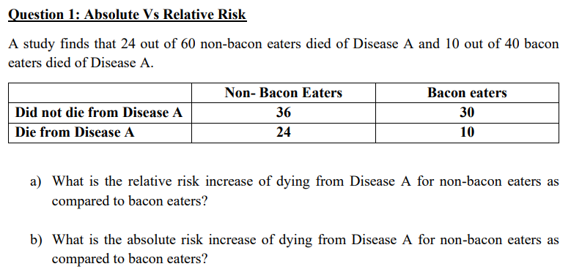

a: ((24/60)-(10/40))/(10/40) = 0.60 or 60%

b: (24/60)-(10/40) = 0.15 or 15%

Question 2: Utility, Expected Utility and Optimal decision

Mr. West attends a casino and is presented with the following rules of the Roulette Wheel.

• A bet cost £100.

• You can only pick 1 number from 36 numbers.

• If the rolling ball lands on your chosen number, you win £10000. Mr. West is not sure if he should play the Roulette Wheel.

a) What is the total expected utility of Mr. West’s decision to play the Roulette Wheel?

b) Should Mr. West play or not play the Roulette Wheel and why? (tip: determine the optimal decision)

• The total expected utility of not playing = 0

Utility of playing the wheel = (9900 \* 1/36) + (-100 \* 35/36) = 177.8

He should play the roulette wheel as the expected utility is higher than not playing it.